**Introduction To Oops Programming**

**Q1:** **What is MongoDB?**

**Ans: MongoDB** is a popular NoSQL database that stores data in a flexible, document-oriented format. Unlike traditional relational databases (like MySQL or PostgreSQL) that use tables and rows, MongoDB stores data in documents, which are similar to JSON objects.

MongoDB is a versatile and scalable database that is well-suited for a wide range of applications. Its flexible document-oriented model, high performance, and rich feature set make it a popular choice for modern data storage needs.

**Q2:** **What is difference between mongo DB and SQL?**

**Ans: MongoDB** and **SQL** (Structured Query Language) are both popular database systems, but they have distinct approaches to storing and managing data.

**MongoDB (NoSQL):**

* **Document-oriented:** Data is stored in flexible JSON-like documents.
* **Schema-less:** No strict schema definition is required, allowing for dynamic changes.
* **High performance:** Optimized for handling large datasets and complex queries.
* **Scalability:** Easily scales horizontally by adding more servers.
* **Use cases:** Content management systems, real-time analytics, IoT applications.

**SQL (Relational):**

* **Relational:** Data is stored in tables with rows and columns.
* **Schema-defined:** Requires a predefined schema, making it more rigid.
* **Strong data integrity:** Enforces data consistency and integrity through constraints and relationships.
* **Transaction support:** Supports ACID properties (Atomicity, Consistency, Isolation, Durability) for reliable transactions.
* **Use cases:** Business applications, financial systems, e-commerce platforms.

**Q3:** **Create database for online shopping app.**

**Ans:**

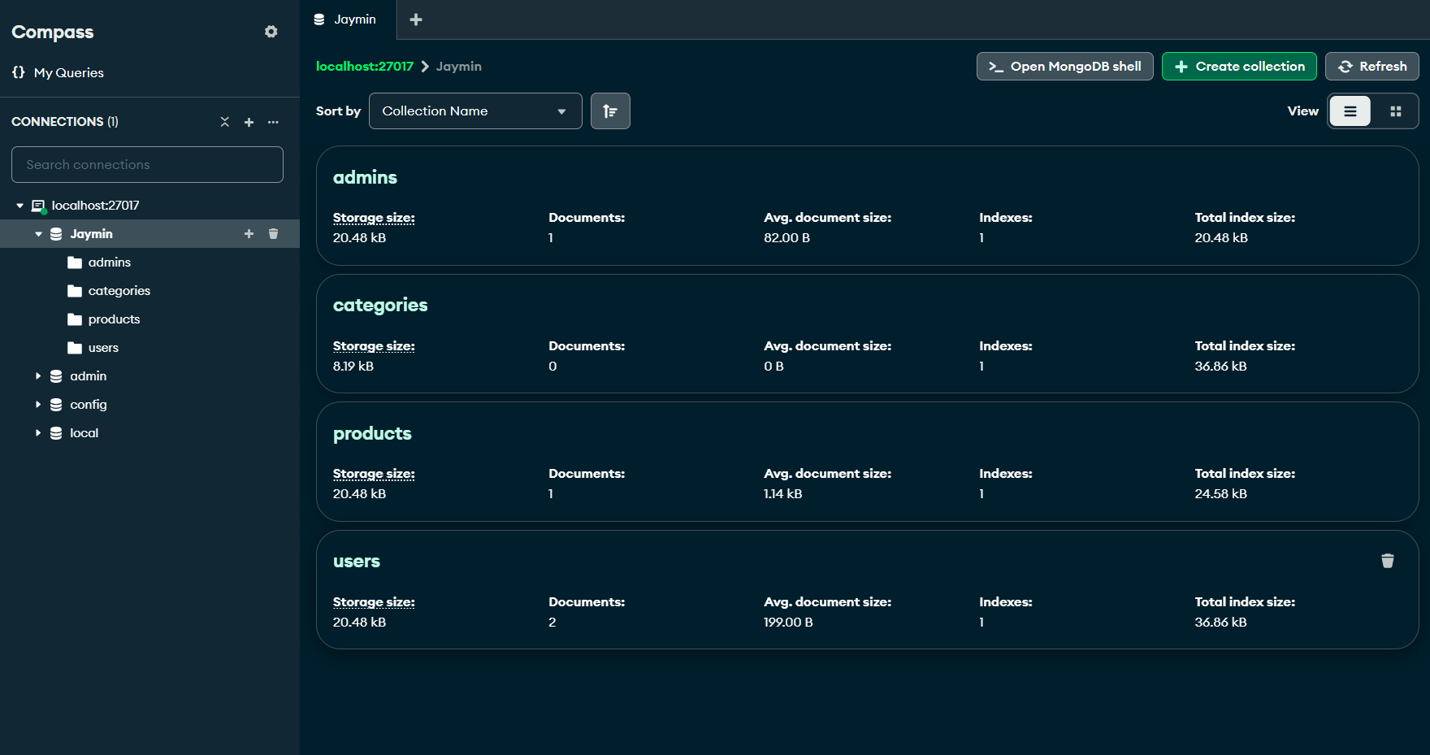

**Q4: Create Require collections for online shopping app and documents.**

**i. User**

**ii. Product category**

**iii. Product**

**iv. Order**

**v. Review**

**Ans:**

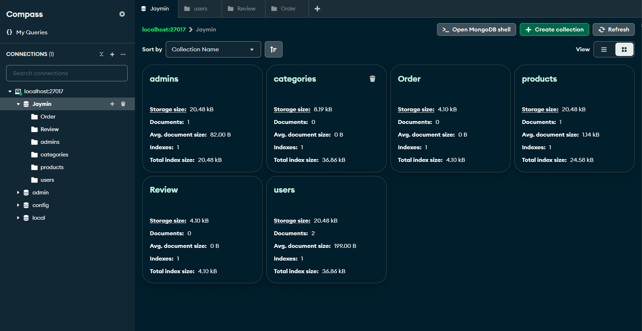

**Q5:** **Write command to show all data from product collections and sort in ascending order.**

**Ans:**

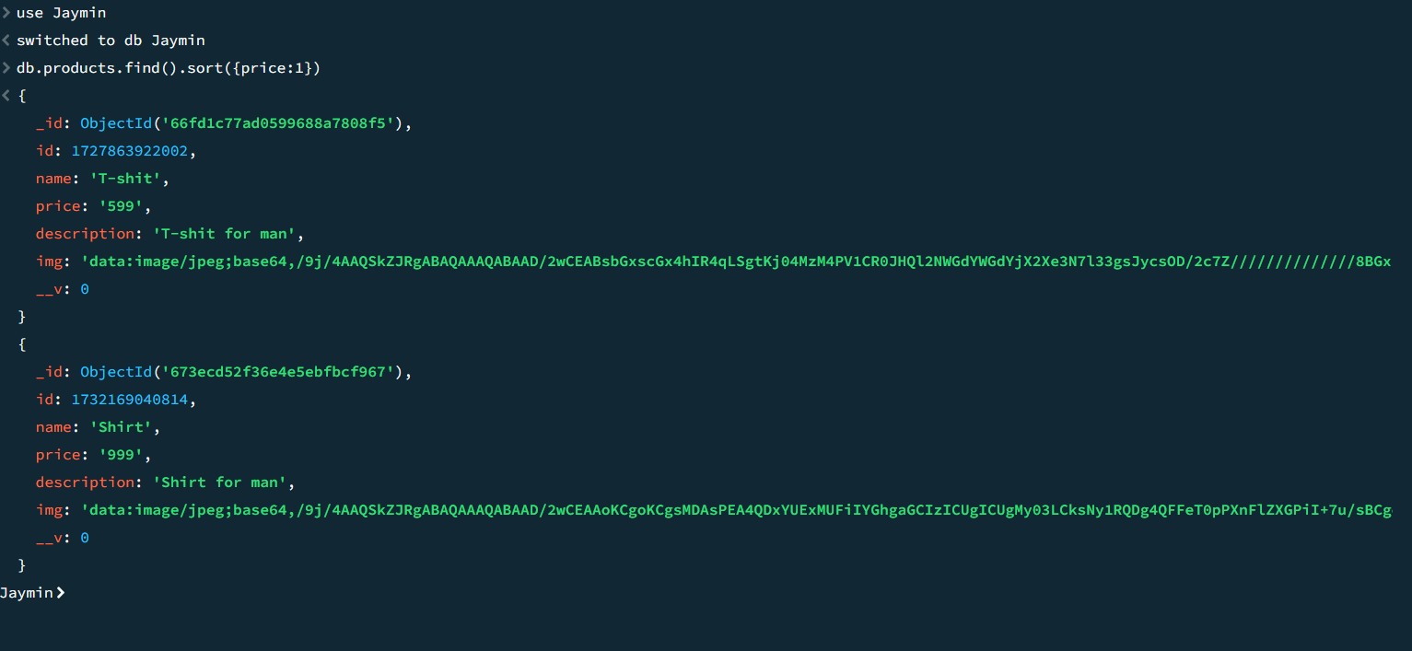

**Q6:** **Update product price for particular product.**

**Ans:**

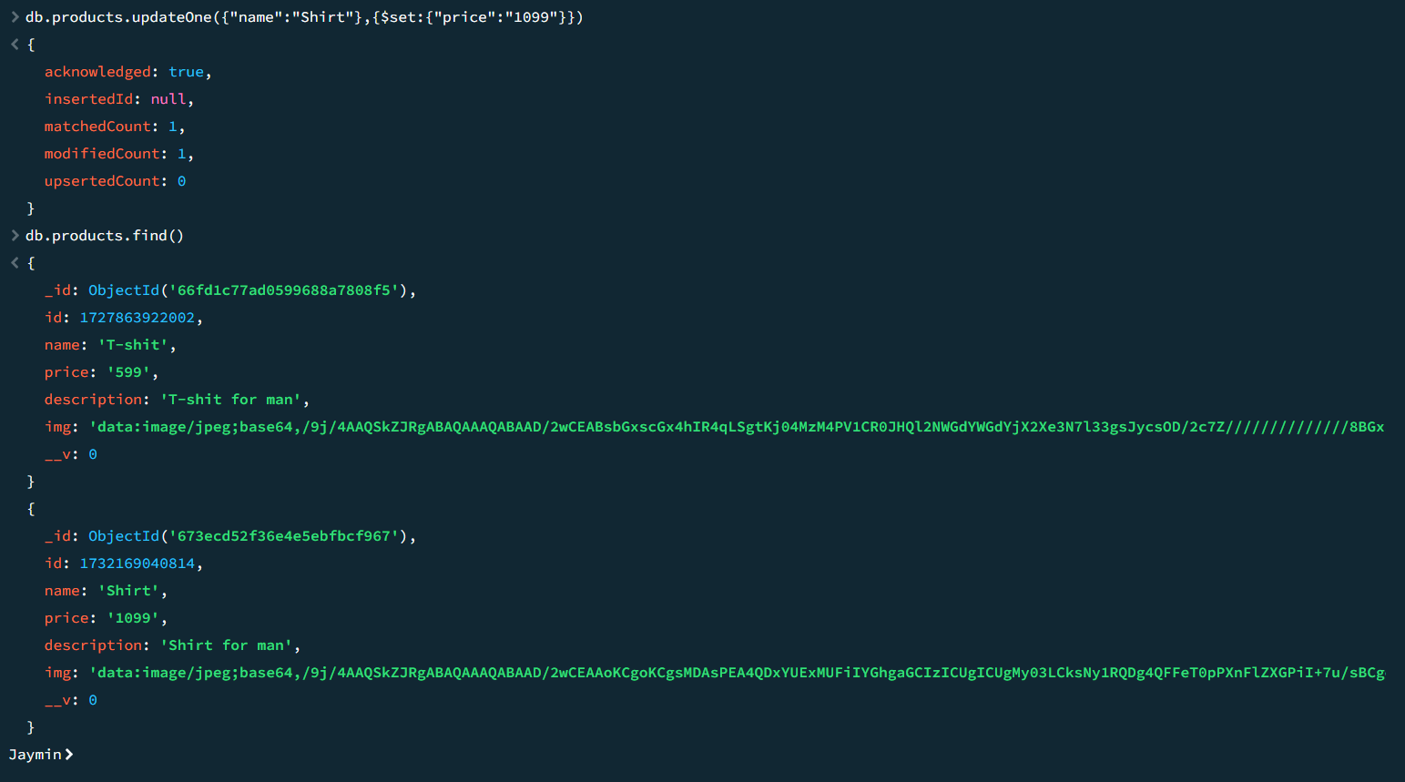

**Q7:** **Write command to delete particular document and collection.**

**Ans:**

